CS 255 System Design Document

UML Diagrams

UML Use Case Diagram
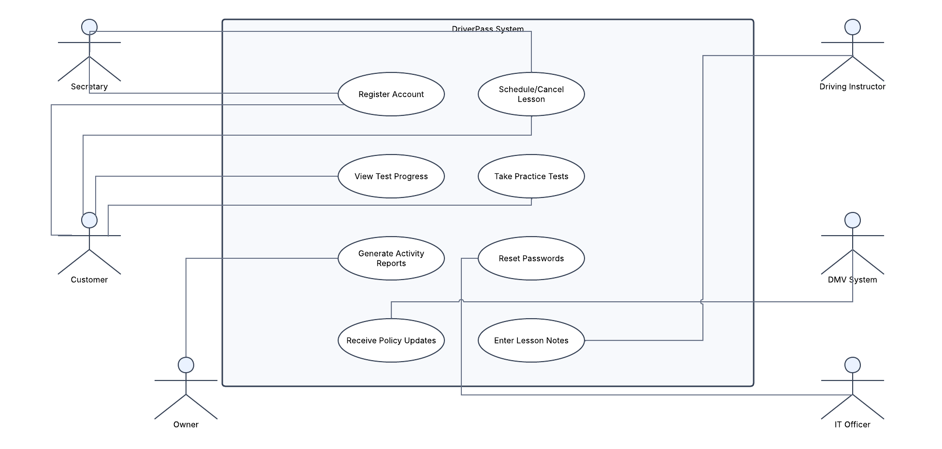

UML Activity Diagrams
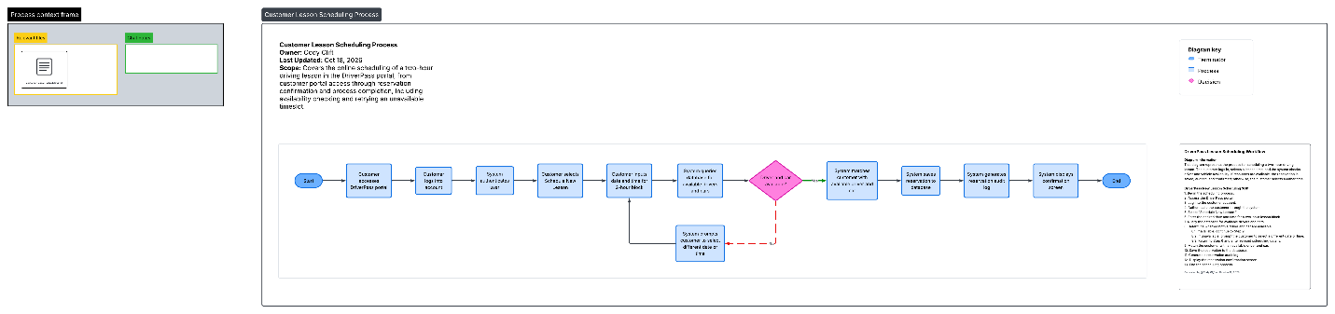
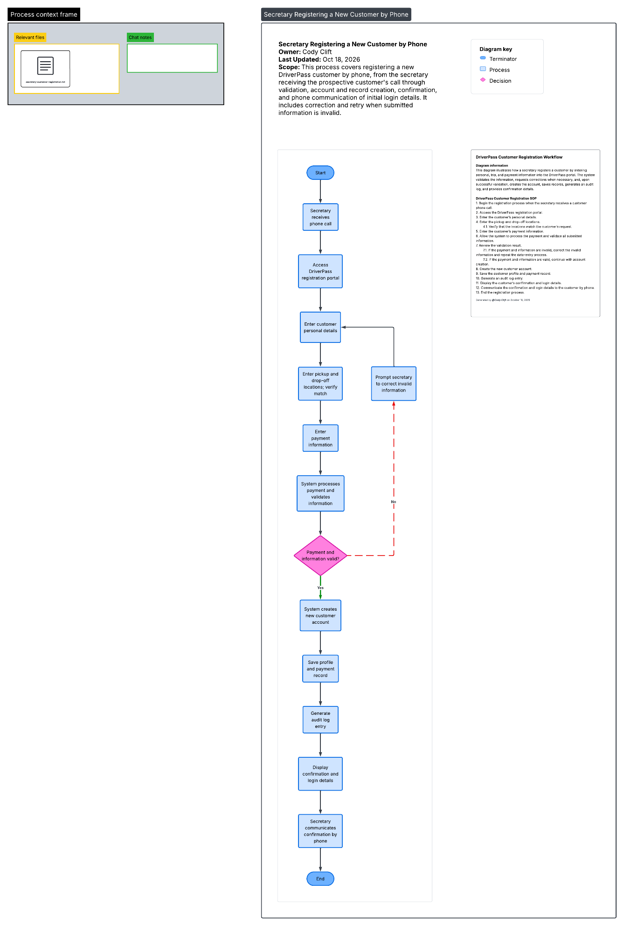

UML Sequence Diagram
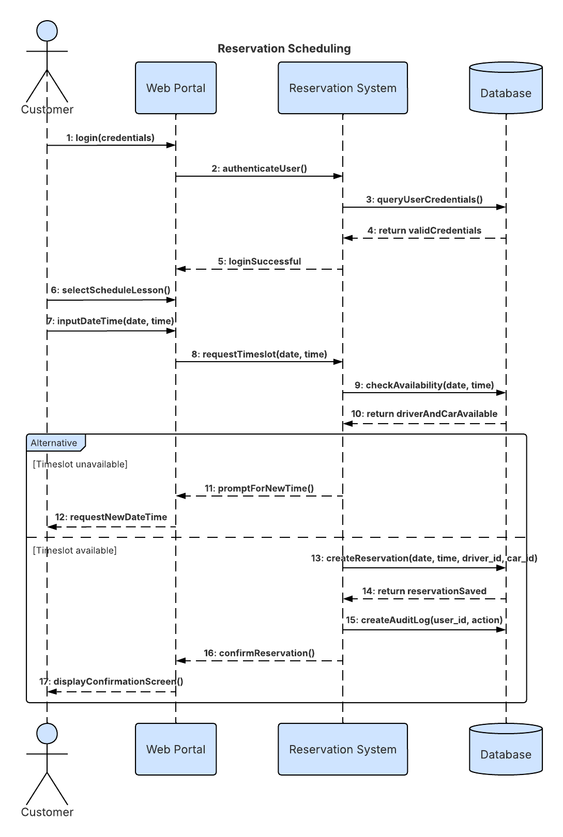

UML Class Diagram
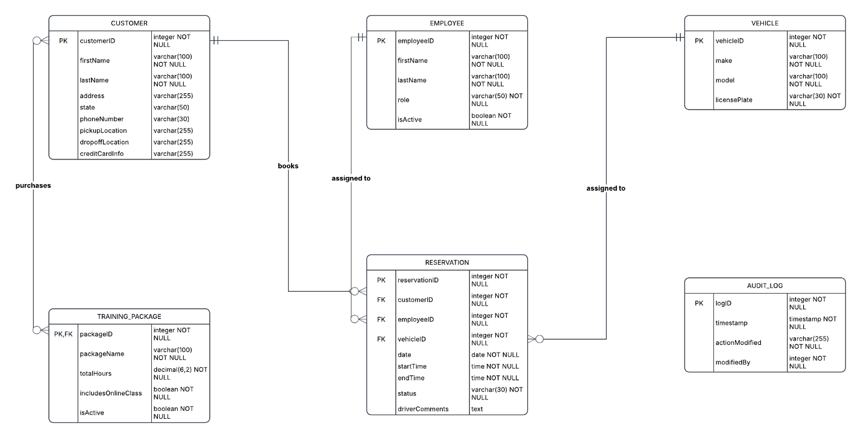

Technical Requirements
Technical Requirements
- Infrastructure: The DriverPass system must be deployed as a cloud-hosted web application to ensure high availability and eliminate the need for on-premises server maintenance. Utilizing a cloud environment ensures automated backups, data redundancy, and baseline server security, fulfilling the IT Officer's requirement to minimize internal technical overhead.
- Hardware: As a cloud-hosted solution, the system requires no specialized on-site servers. End-users (the owner, staff, and customers) will access the portal using their own standard internet-connected hardware, including desktop computers, laptops, and mobile devices.
- Software: The front-end application requires only a standard modern web browser for user access. The back-end requires a Relational Database Management System (RDBMS), such as MySQL or PostgreSQL, to securely store and enforce the structured data relationships defined in the Class Diagram (Customers, Employees, Vehicles, Reservations, and Audit Logs). The software must also feature an export module allowing administrators to download system data into spreadsheet-compatible formats (e.g., CSV or XLSX) for offline use.
- Tools & Integration: The system must incorporate an Application Programming Interface (API) to connect with the local Department of Motor Vehicles (DMV) database, ensuring automated delivery of updated driving rules, policies, and practice test questions. Furthermore, a Role-Based Access Control (RBAC) tool must be implemented to enforce security, granting the IT Officer full administrative rights (including password resets and user blocking) while restricting other users to their designated scheduling and profile management modules.

